**COURSE :**Digital Marketing

**ZONE :**17

**MENTOR :**Abdul Malik.M

**TEAM ID :**NM2023TMIDO2667

**TEAM MEMBERS :**

1.Beni jeshna A – 9312E1300E841E2AF494DABBE39822A5 (Team Leader).

2.Deepika J S – 31F3036658BC918A437434DE374F0C54

3.Atheesha T – C2654ED32AAA5CCA117448785D8F1594

4.Aswini Muratha E – 0426A443B64EDDDAF7C4EE4FD1CD4D34

**PROJECT :**

Google Analytics : Embed a Google Analytics Code on your Website.

**Brand Name :**Aurora Jewels

**Category :**Beauty and Fitness.

**Target Audience :**All

**Email :**[aurorajewels23@gmail.com](mailto:aurorajewels23@gmail.com)

**Create a Blog Website :**<https://www.blogger.com/blog/posts/9182562971176520325>

**Blog Address URL :**

<https://aurorajewels23.blogspot.com/2023/10/be-trend-setter.html>

**Google Analysis Tracking Code :**

<!-- Google tag (gtag.js) -->

<script async src="https://www.googletagmanager.com/gtag/js?id=G-9QQW0DP4BQ"></script>

<script>

window.dataLayer = window.dataLayer || [];

function gtag(){dataLayer.push(arguments);}

gtag('js', new Date());

gtag('config', 'G-9QQW0DP4BQ');

</script>

**DOCUMENTATION :**

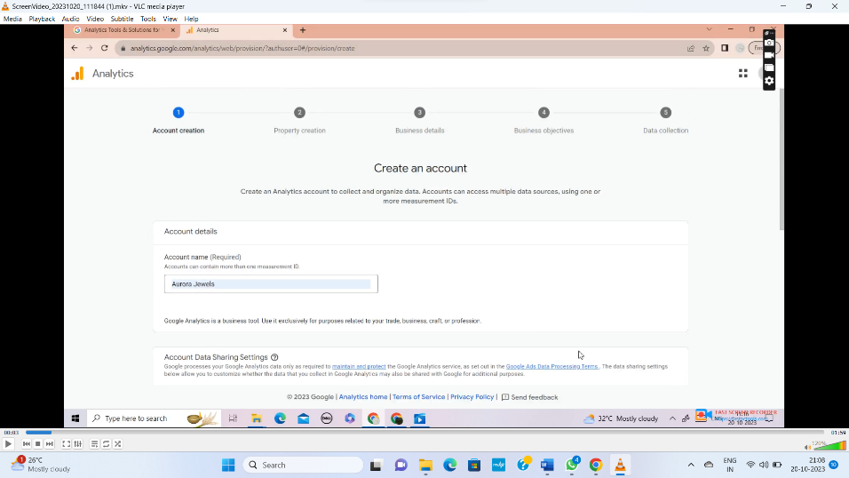**ti**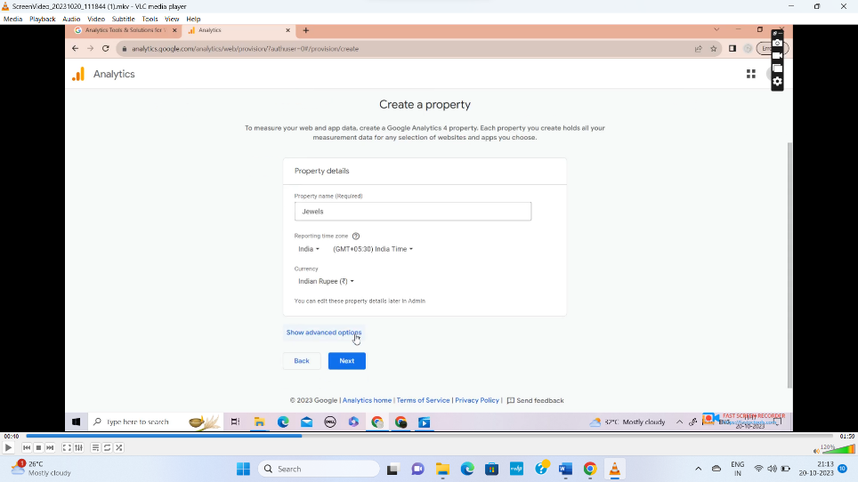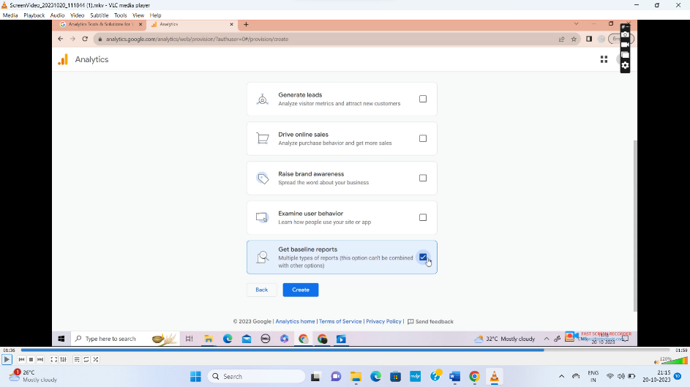

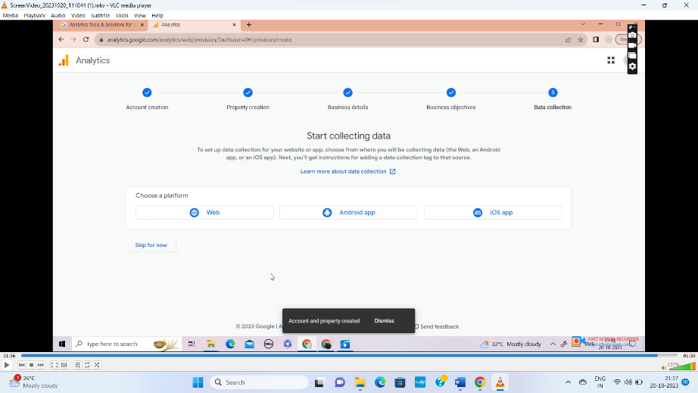

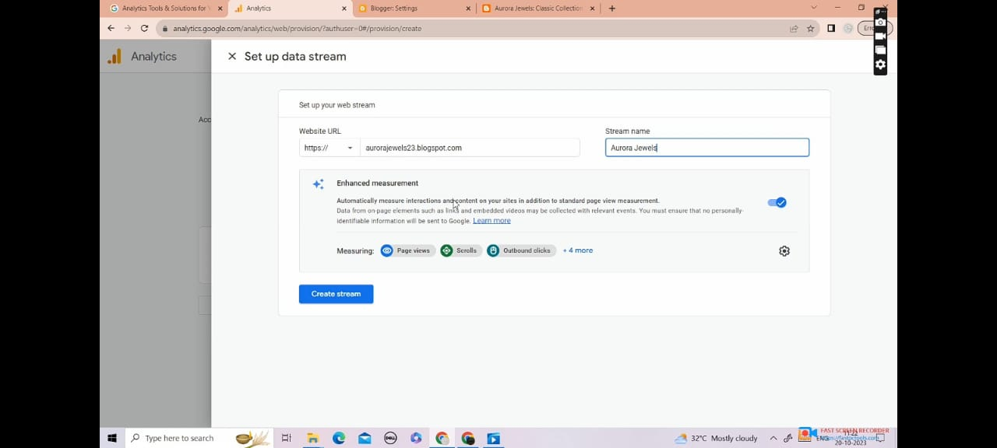

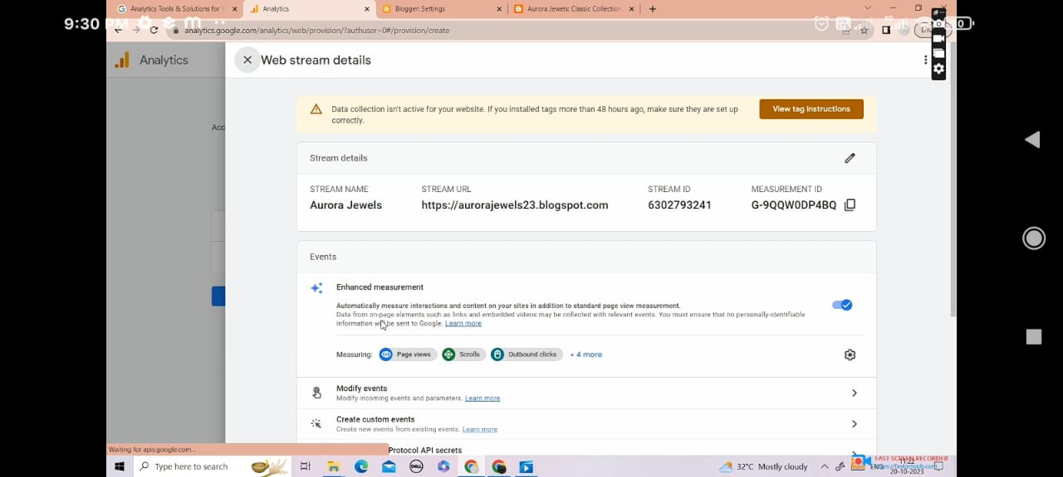

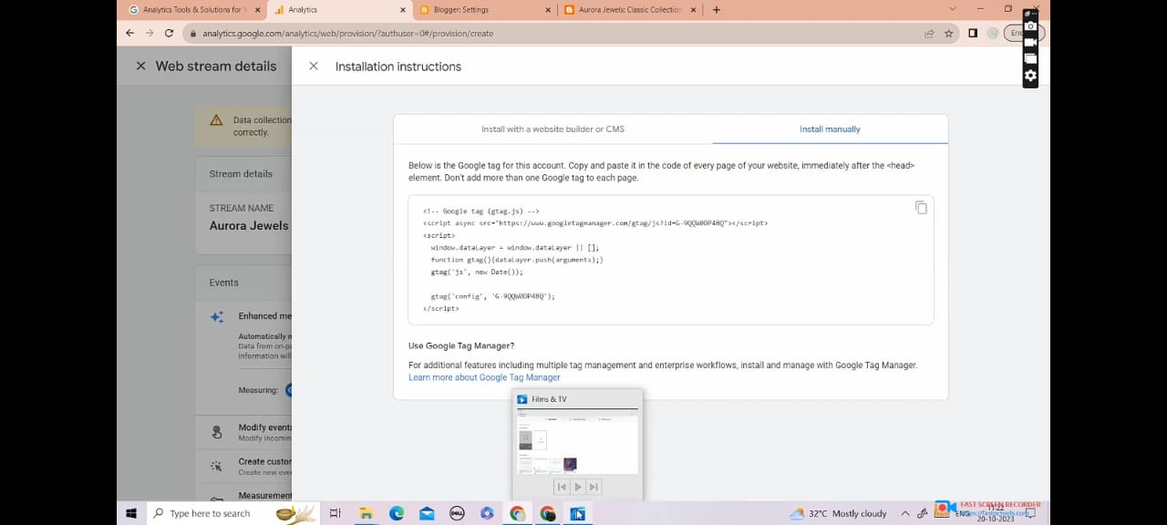

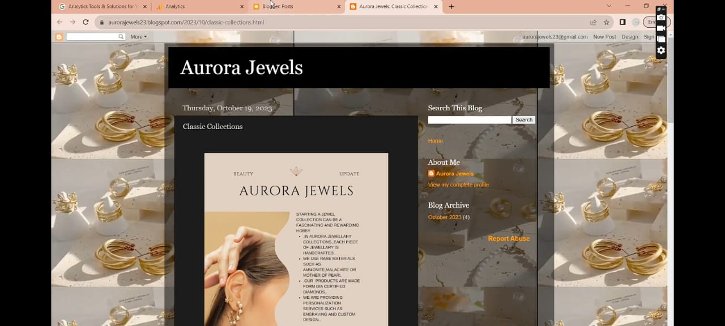

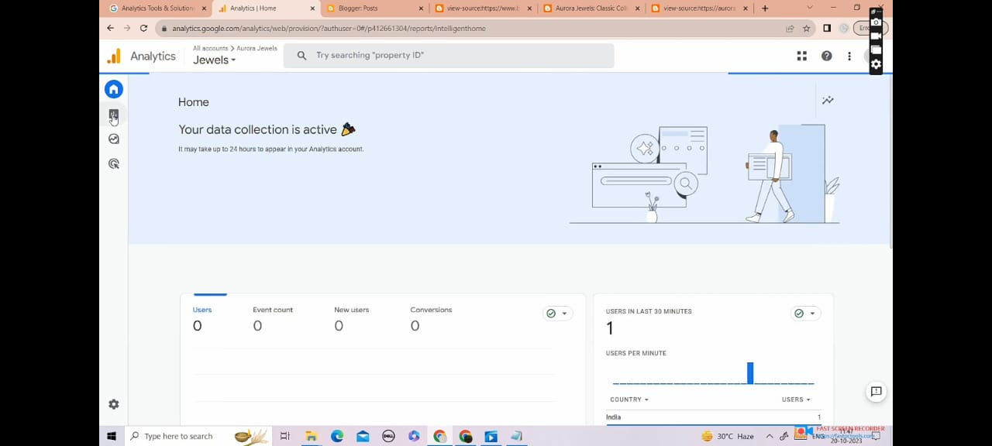

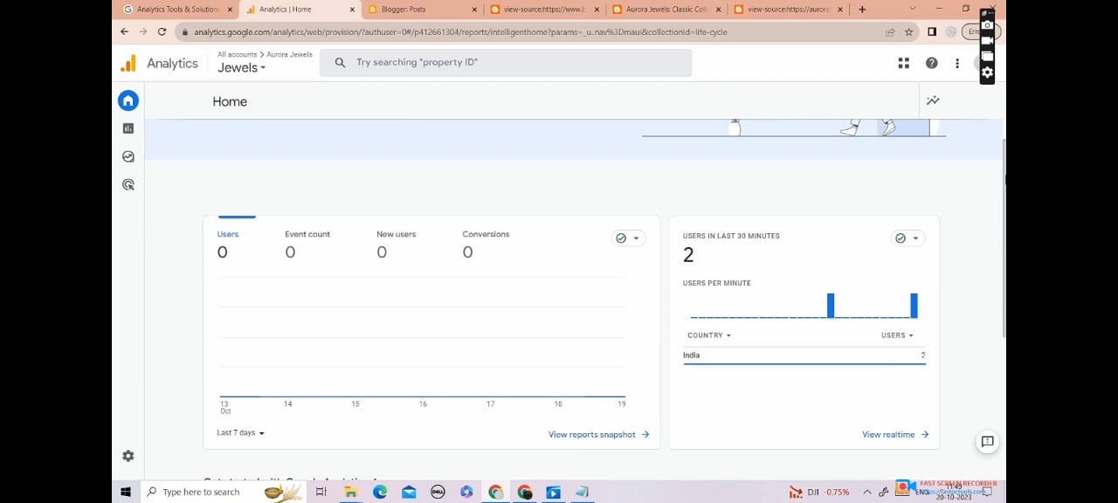

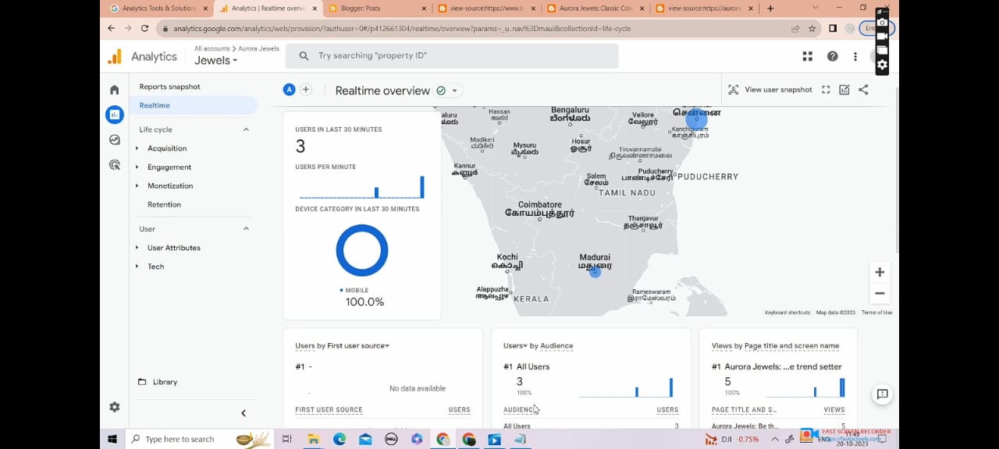

**DEMO LINK :**

[**https://drive.google.com/file/d/1HqlBSk0Jx9RZGdjv0X5zOsGXvUDQ3tci/view?usp=drivesdk**](https://drive.google.com/file/d/1HqlBSk0Jx9RZGdjv0X5zOsGXvUDQ3tci/view?usp=drivesdk)